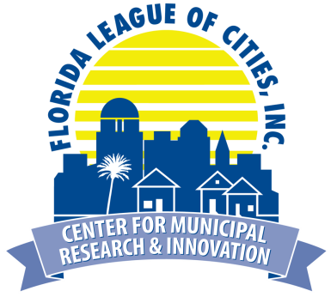
FLC Center for Municipal Research & Innovation
7th Annual Summer Research Symposium
Disruptive Technology: Impacts on Local Government

Wednesday, August 15, 2018 | 8:30 a.m. - 1:00 p.m.
The Diplomat Beach Resort | Hollywood

New technologies are rapidly replacing established methods of service delivery and municipal governance. Innovations such as autonomous vehicles, broadband WiFi and the sharing economy are impacting the way residents and visitors interact with the city. In response, local leaders are seeking ways to embrace these technologies while also balancing property rights and preserving the unique character of their individual communities. In some areas, this has become contentious as corporate interests seek to gain market advantage by circumventing local control through statewide regulation. Join us as we discuss local and nationwide trends, dive deep into the issue of home-sharing and short-term rentals, present options and tools cities can use to work with disruptive technology companies, and explore the effects – both positive and negative – these technologies are having on our communities.

This research symposium is designed for city managers, innovation officers, municipal attorneys and elected leaders to better understand and cope with the impacts disruptive technologies have on municipal government. The event is free for League members and research partners, but pre-registration is required.

Please type or print the information below
Name:
First Last
First Name or Nickname: Title:
as you wish it to appear on badge
Municipality/Affiliation:
Phone: Email:
provide email of person who should receive confirmation information

Registration Deadline: Wednesday, August 8, 2018 (space is limited)
Registration Fee: There is no cost to attend, but pre-registration is required. Breakfast and lunch will be provided.
No-Show Fee: If you register and do not attend the symposium, your city will be invoiced a $45 no-show fee. Cancellations must be received by Thursday, August 9 to avoid the no-show fee. Registration transfers are accepted.
Return completed registration form to Liane Schrader at lschrader@flcities.com or fax 850-222-3806.
Confirmations will be emailed once registration is received. Contact Liane Schrader at 850-222-9684 with any questions regarding registration or the symposium.
Special Needs: If you are physically challenged and require special services, or if you have special dietary needs (ex. vegetarian, food allergies), please attach a written description to your registration form.

